Part 1
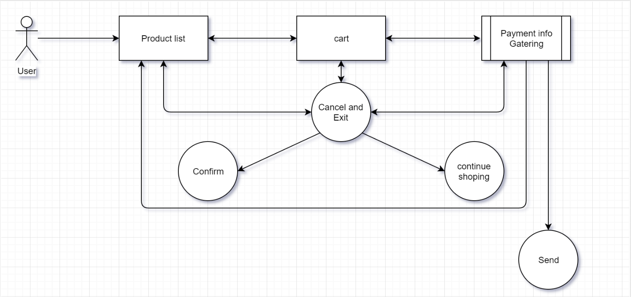
User select product, add it to cart or cancel the whole thing from cart either goes to payment or cancel the purchase, from payment center use can go back to product list, cancel or pay from cancel page use can confirm it or continue shopping which would send the use back to whatever page he was on.

Part 4
Welcome to the most interactive shopping cart to have ever been build. This shopping cart does not have a user registration and is setup for a user looking to make a purchase and move on. From the first page the index page you are presented with the product list, once you select one you are moved to the detail page where you get more info about the product from there you can decide to go back to the list or add it to the cart, once you reach the cart you can either increase the number of each product, remove a product and even pay. Changing the quantity of a product to zero will remove it from the cart. In the future I would like to make this cart better where an account would be created automatically for a user after their first purchase and the system would remember them and interact with them more like a human that a machine. It would even go as far as to send them the game and if they like it keep it and have the cost processed.

